MAADI BRITISH
INTERNATIONAL SCHOOL

YEAR 10 HISTORY
END OF YEAR ASSESSMENT

QUESTION BOOKLET

3. Germany: The development of dictatorship 1918-45
a) Study Extract C.

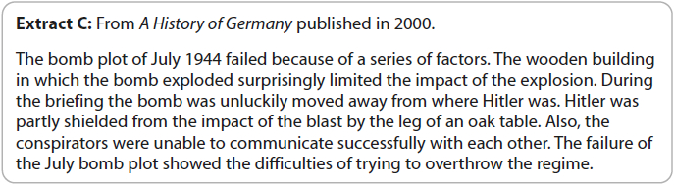

What impression does the author give about the July Bomb Plot (1944)?

You must use Extract C to explain your answer.
- marks)

b) Explain two effects of hyperinflation on Germany.

(8 marks)

EITHER

c. i)
'The main reason for Germany's recovery, in the years 1924–29, was the Dawes Plan.'

How far do you agree? Explain your answer.

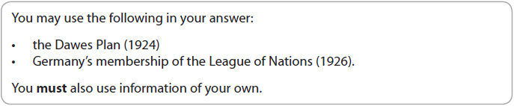

(16 marks)

OR

c.ii)

'The most significant method of control used by the Nazis in Germany, in the years 1933–39, was censorship.'
How far do you agree? Explain your answer.
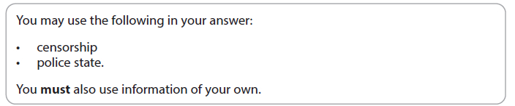
(16 marks)

(Total for Question 3 = 30 marks)

6. A world divided: superpower relations, 1943-72
Study Extract F.
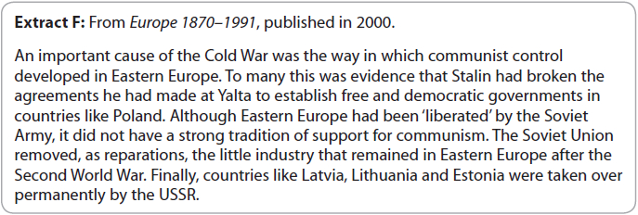
a) What impression does the author give about the reason for the start of the Cold War.

You must use Extract F to explain your answer.
- marks)

b) Explain two effects of the U2 incident (1960) on relations between the US and USSR.

(8 marks)

EITHER

c.i)

'The most significant development in the Cold War, in the years 1947–49, was the Truman Doctrine.'

How far do you agree?

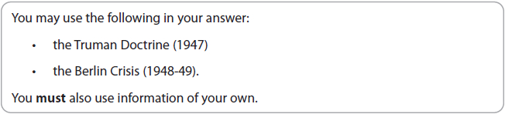
- (16 marks)

OR
c. ii)

'The SALT 1 Treaty was the main consequence of the thaw in superpower relations in the years 1963–72.'
How far do you agree? Explain your answer.

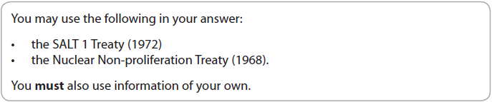(16 marks)

(Total for Question 6 = 30 marks)

--------------------------------------------END OF EXAMINATION-------------------------------------------------

----------------------------------------------------BLANK PAGE------------------------------------------------------

